ADITHYA R
192311369

25.Database as a Service (DaaS) create and configure a new VM Image in any Public Cloud Service Provider using Azure.
AIM: To demonstrate Database as a Service by creating and configuring a managed database instance using Microsoft Azure
Procedure:
STEP 1: Login to Azure Portal
- Open browser
- Go to https://portal.azure.com
- Login with Azure credentials

STEP 2: Create a Resource Group
- Search Resource Groups → Click Create
- Enter:
  - Resource Group Name: DBaaS-RG
  - Region: Central India (or nearest)
- Click Review + Create → Create

STEP 3: Create a Managed Database (Azure SQL Database)
- Click Create a Resource
- Search SQL Database → Click Create

Fill in Basic Details:
- Subscription: Select subscription
- Resource Group: DBaaS-RG
- Database Name: DaaSDemoDB
- Server: Click Create New → Name: daas-demo-server
  - Admin Username: dbadmin
  - Password: StrongPassword123
  - Location: Same as Resource Group
- Compute + Storage: Basic Tier (2 vCores, 5 GB storage)
Click Review + Create → Create
⏳ Deployment takes 2–5 minutes.

STEP 4: Configure Firewall
- Go to SQL Database → Set server firewall
- Add client IP → Click Save
  - This allows your desktop to connect

STEP 5: Connect to the Database
- Use Azure Data Studio or SQL Server Management Studio (SSMS)
- Server Name: daas-demo-server.database.windows.net
- Authentication: SQL Login
- Username / Password: As created
- Database: DaaSDemoDB
✅ Connection successful → you can create tables, run queries, and manage data.
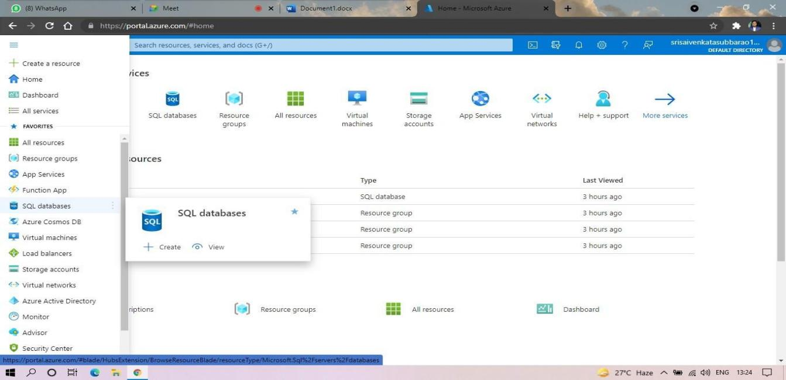

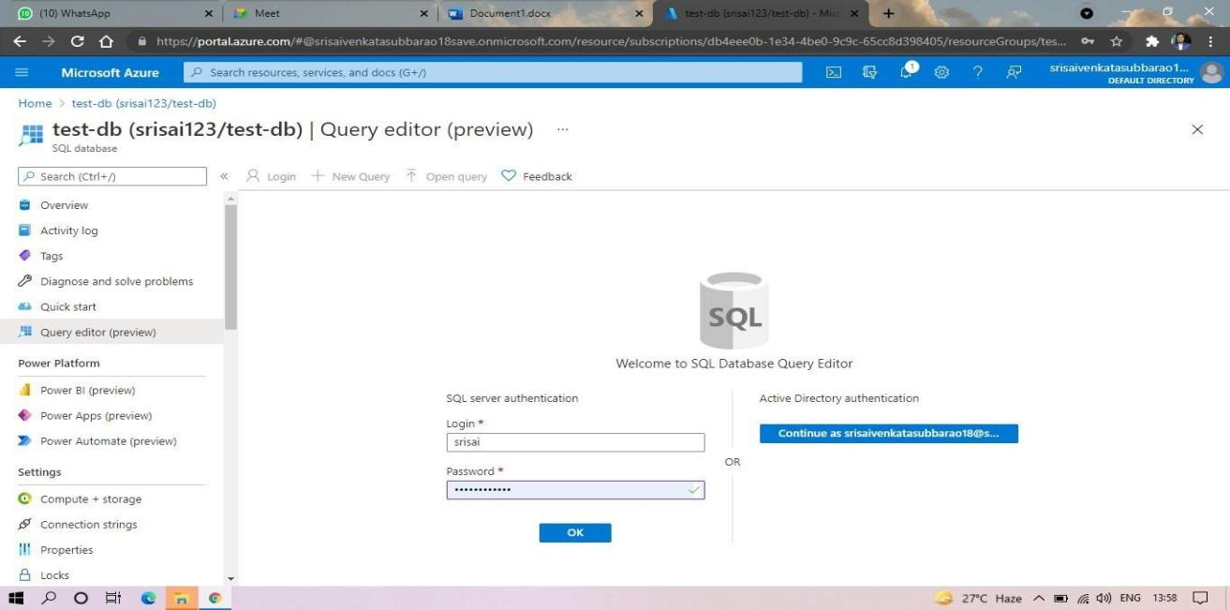
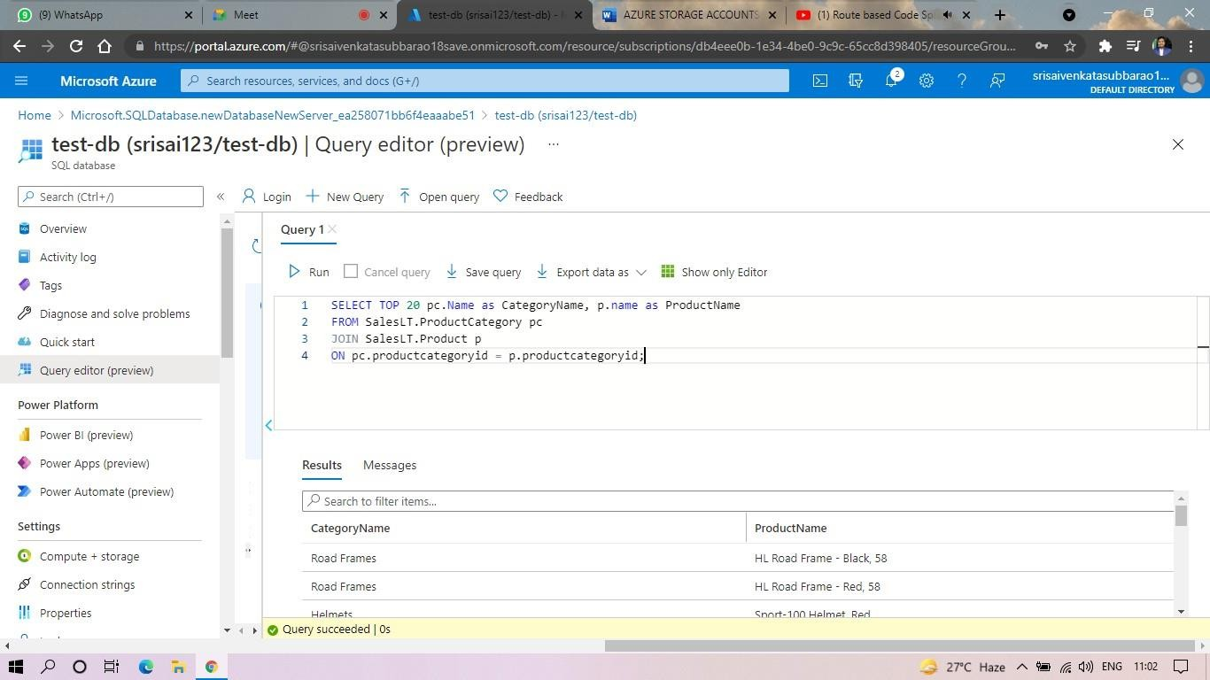

RESULT:
- Azure SQL Database was successfully created and configured as a managed database.
- The database instance was accessible from a local client without managing the underlying OS or VM.
Thus, Database as a Service (DBaaS) was successfully demonstrated using Microsoft Azure.

